Subject: Programming with Java
ASSIGNMENT No : 1
TITLE : Develop an application based on Java environment setup, JDK/JRE/JVM, variables, methods and constructors. and demonstrate the implementation of the concepts through suitable examples.
Problem Statement
Develop an application based on Java environment setup, JDK/JRE/JVM, variables, methods and constructors. and demonstrate the implementation of the concepts through suitable examples.
Learning Objectives
Understand the theoretical concepts, implement them in Java programs, analyze outputs, and apply the concepts to solve practical programming problems.
Theory
Java environment setup, JDK/JRE/JVM, variables, methods and constructors. forms an important component of Java programming. Students should understand the underlying concepts, architecture, advantages, use cases, and implementation methodology. The exercise should focus on understanding the design principles, coding practices, execution flow, and practical applications of these concepts in software development. Detailed study should include syntax, APIs, execution process, and real-world applications.

Output Screenshots
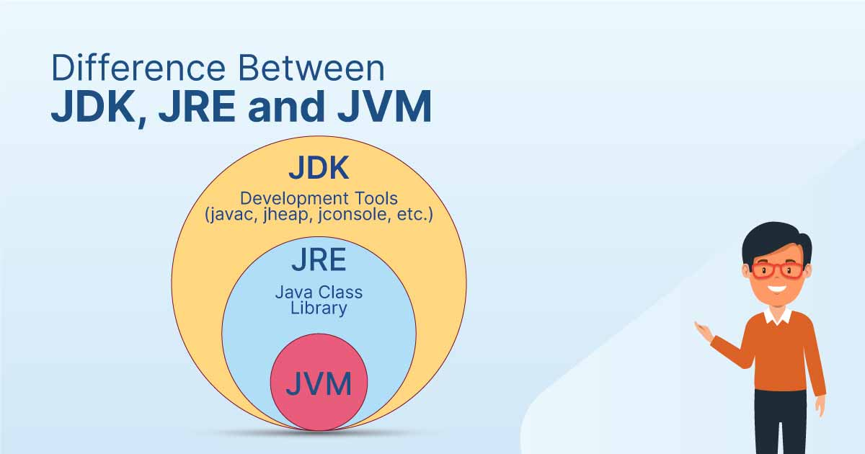 | 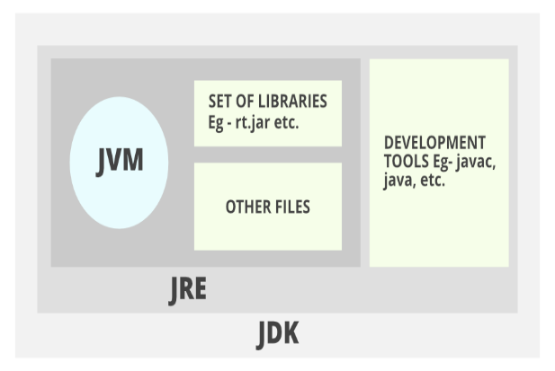
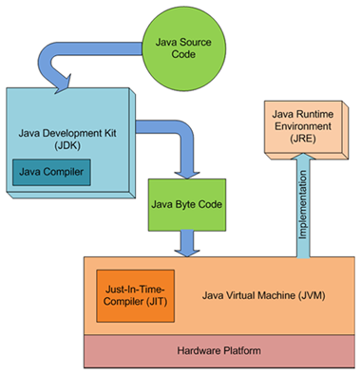 | 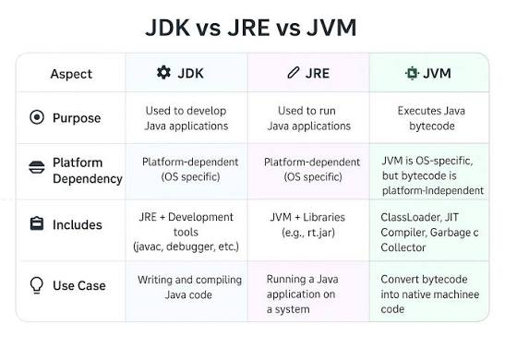

Conclusion
In this assignment, I studied the Java programming environment and understood the roles of JDK, JRE, and JVM in compiling and executing Java programs. I learned how to declare and use variables, create methods to perform specific tasks, and use constructors to initialize objects. By implementing these concepts through Java programs, I gained practical knowledge of Java syntax, program execution, and object-oriented programming basics. This assignment strengthened my understanding of Java fundamentals, which serve as the foundation for developing efficient, reliable, and platform-independent applications.

Questions & Answers
- Explain the main concept used in Java environment setup, variables and methods.
Answer:
The Java programming environment consists of three important components: JDK (Java Development Kit), JRE (Java Runtime Environment), and JVM (Java Virtual Machine).
- JDK is a complete software package used by developers to write, compile, debug, and run Java programs. It includes the compiler (javac), debugger, and other development tools.
- JRE provides the runtime environment and required libraries to execute Java applications. It contains the JVM and supporting files but does not include development tools.
- JVM is responsible for converting Java bytecode into machine code and executing it. It also manages memory, security, and garbage collection, making Java platform-independent.
A variable is a named memory location used to store data such as numbers, characters, or strings. Variables allow programs to store, modify, and retrieve information during execution.
A method is a block of code designed to perform a specific task. Methods improve code reusability, reduce duplication, and make programs easier to understand and maintain. They can accept parameters, perform operations, and return values when required.

- What are the advantages of using Java variables and methods?
Answer:
Advantages of Variables:
- Type Safety: Java is statically typed, meaning the compiler checks variable types at compile-time to prevent data corruption and unexpected structural runtime crashes.
- Scope Control: Variables can be constrained to specific scopes (local, instance, or class/static levels), which optimizes active memory distribution.
- Dynamic State Management: They allow objects to effectively maintain, track, and update their states throughout the lifecycle of the execution thread.
Advantages of Methods:
- Code Reusability: Logic written once inside a method can be invoked thousands of times across different parts of the application, eliminating redundant blocks.
- Ease of Maintenance: If an update to a functional logic block is required, it only needs to be modified within that isolated method rather than everywhere the process occurs.
- High Readability: Complex processes are neatly organized behind descriptive method signatures (e.g., calculateNetSalary()), making the codebase self-documenting.

3. How can this implementation be improved?
Answer:
A fundamental implementation of these concepts can be upgraded to industry standards by applying advanced object-oriented design patterns:
- Encapsulation: Restricting direct access to class variables by declaring them as private and routing data mutations strictly through controlled public getter and setter methods.
- Constructor Overloading: Providing multiple constructors with distinct parameter signatures to allow flexible object initialization depending on the availability of initial state data.
- Memory Optimization via static: Labeling universal constants or globally shared operations with the static modifier to belong to the class blueprint rather than occupying repetitive memory allocations across instances.
- Enforcing Immutability: Utilizing the final keyword for variables whose states must remain secure and fixed after initial instantiation to minimize side effects in concurrent multi-threaded environments.

4. What are the real-world applications?
Answer:
Java is one of the most widely used programming languages due to its platform independence, security, and reliability. Some important real-world applications are:
- Desktop Applications: Software such as calculators, text editors, inventory management systems, and banking applications.
- Web Applications: Enterprise websites and web services developed using Java frameworks like Spring and Hibernate.
- Android Application Development: Java has been widely used for developing Android mobile applications.
- Banking and Financial Systems: Java provides high security and reliability for online banking, ATM software, and payment systems.
- Enterprise Applications: Large organizations use Java to build scalable business applications such as ERP and CRM systems.
- Cloud Computing: Java is commonly used to develop cloud-based services and distributed applications.
- E-commerce Platforms: Online shopping websites and payment gateways use Java for secure transaction processing.
- Educational and Scientific Applications: Java is used for simulation software, educational tools, research applications, and automation systems.
- Game Development and IoT: Java is also used in game development, embedded systems, and Internet of Things (IoT) applications.

